DA Assignment 1

Bar Chart – Total Sales by Product Line and Branch
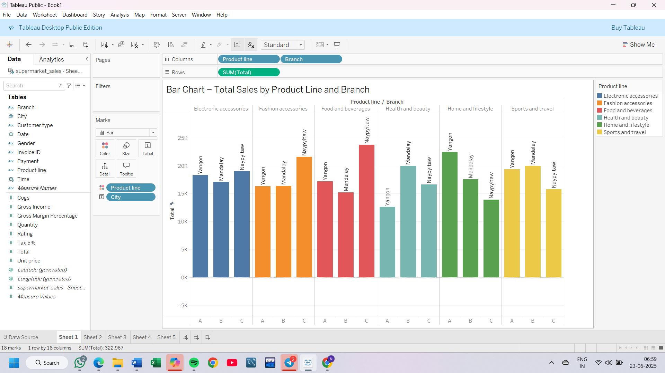

Pie Chart – Payment Method Distribution
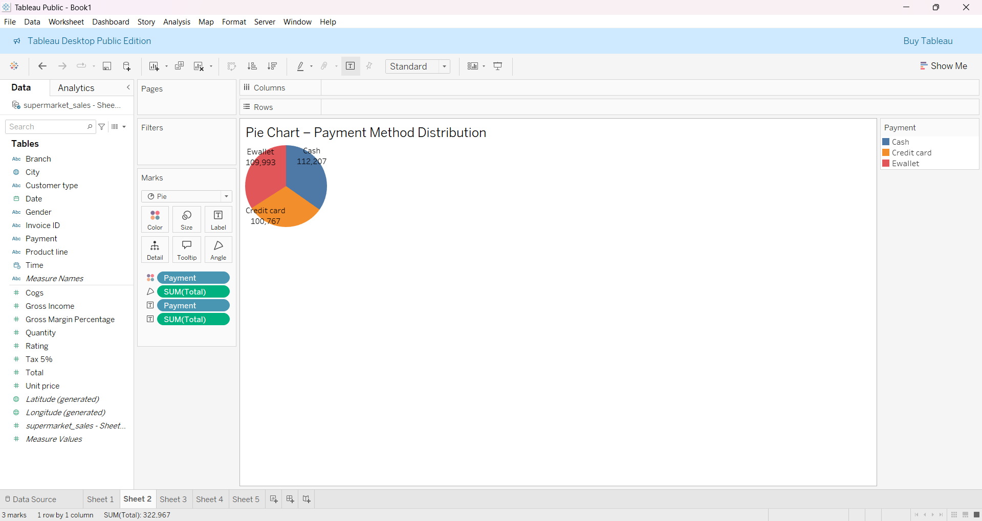

Stacked Bar Chart – Total Sales by Branch and Customer Type
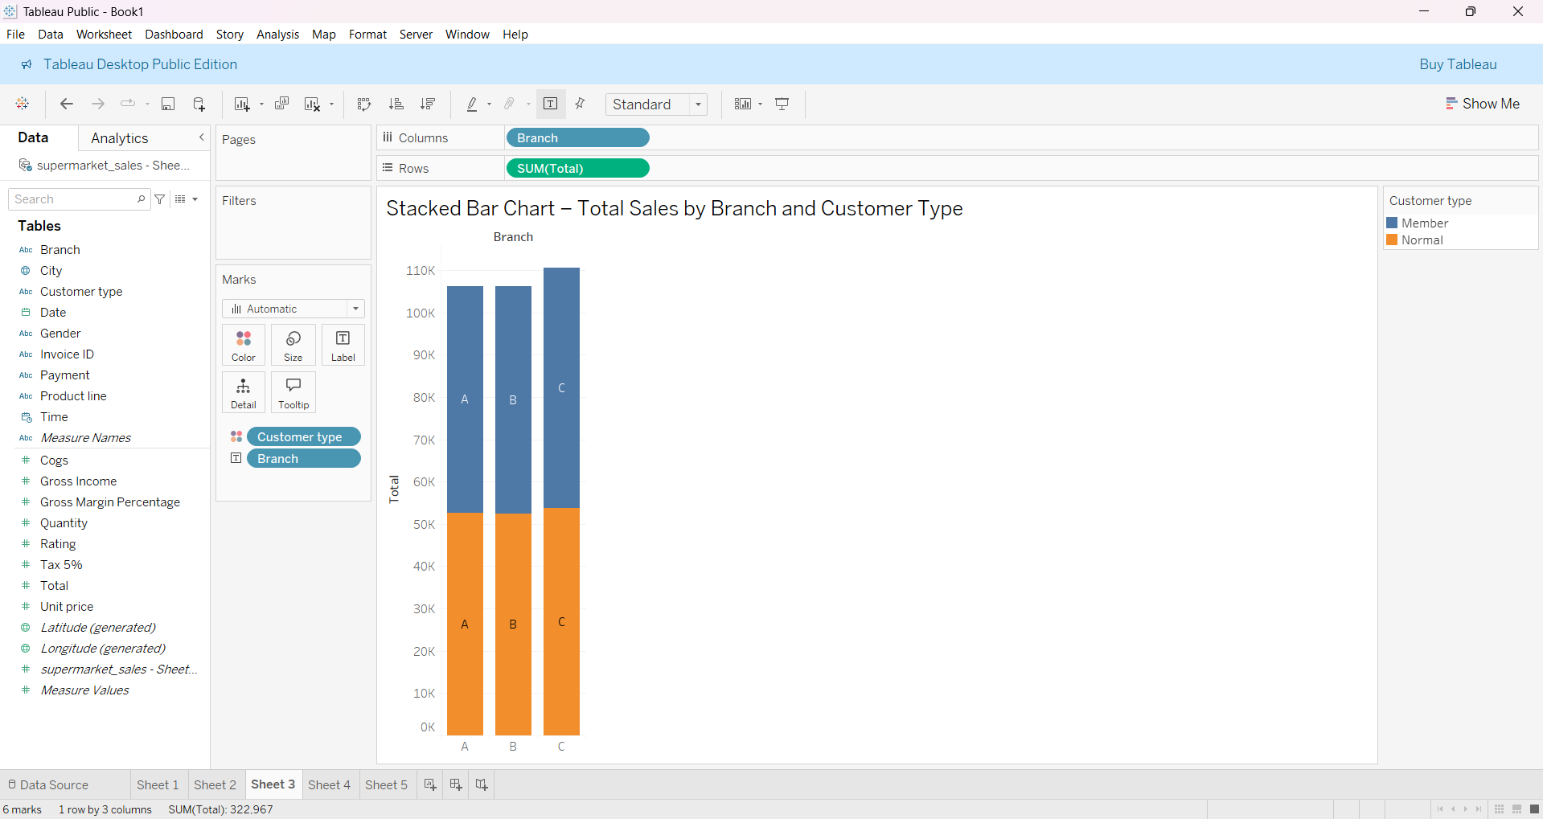

Line Chart – Daily Total Sales by Branch
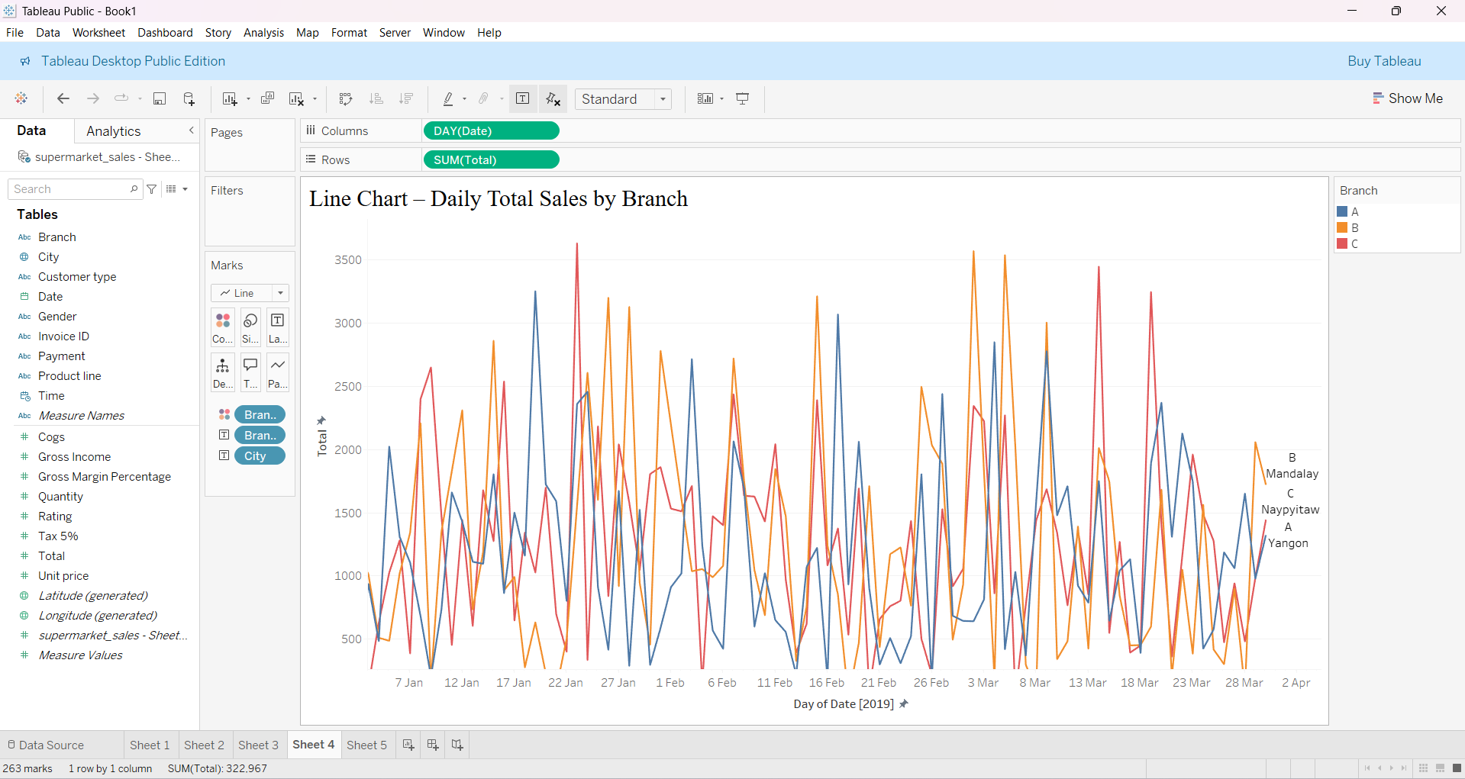

Bubble Chart – Gross Income by Product Line and City
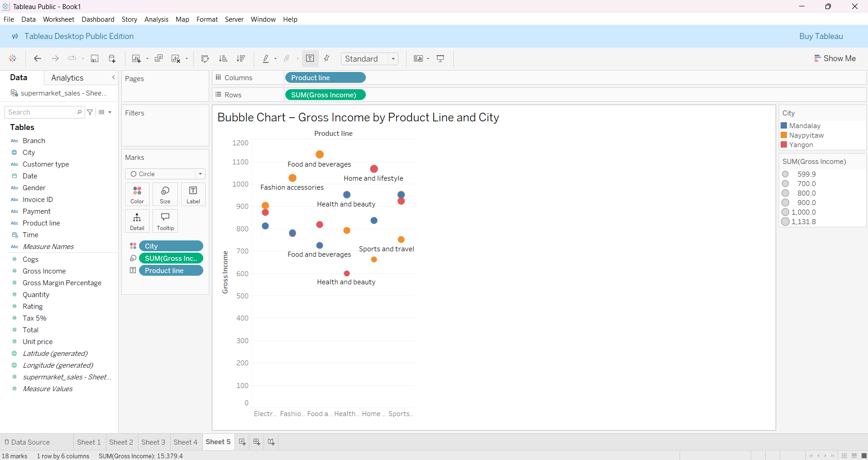

Submitted by
Nallapu Umamaheswar Reddy
22BFA04475

